What's happenin'at the Deaf Church on Sundays ???

SUNDAY SCHOOL -- 9:45am
In FELLOWSHIP HALL - 5324 Canal Blvd (downstairs door, off Hawthorne Place)

SUNDAY WORSHIP SERVICE -- 10:45am
in BIG bldg facing Canal Blvd (5320 Canal Blvd)

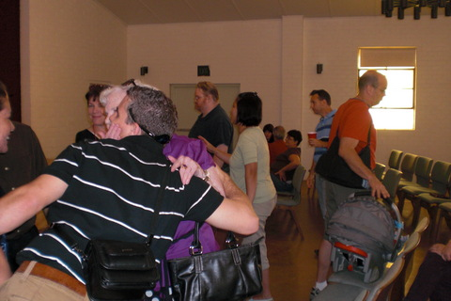
All are welcomed to attend. Come ready to chat about God and your
questions about the Bible. Bring your Bible, if you have one. If you
don't have a Bible, we will give you on.
Sincerely, Pastor John Lovas
VP # 504 273 1152

E-mail: jclovas@gmail. com
AIM: jclovas
Text #: 504-275-9707

Pager e-mail: jclovaspager@ gmail.com
Church address: 5320 and 5324 Canal Blvd, N.O., LA 70124
http://bblovas1.wordpress.com

What's happenin'at the Deaf Church on Wednesdays ???

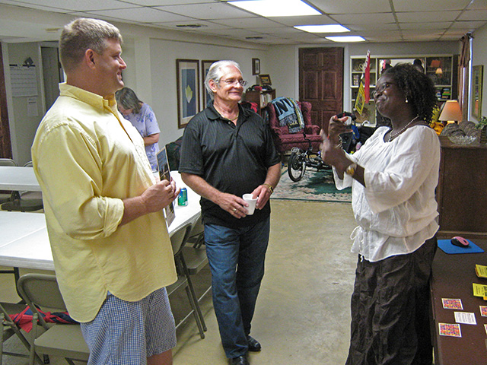
Wednesday Bible Chat at 7pm to pray & discuss the Bible!

WHERE: In Meeting Hall
5324 Canal Blvd (downstairs door, facing Hawthorne Place)
All are welcomed to attend. Come ready to chat about God and your
questions about the Bible. Bring your Bible, if you have one. If you
don't have a Bible, we will give you on.
Sincerely, Pastor John Lovas
VP # 504 273 1152

E-mail: jclovas@gmail. Com, AIM: jclovas
Text #: 504-275-9707

Pager e-mail: jclovaspager@ gmail.com
Church address: 5320 and 5324 Canal Blvd, N.O., LA 70124
http://bblovas1.wordpress.com
What's happenin'at the Deaf Church on other days ???

Community & World Outreach Programs
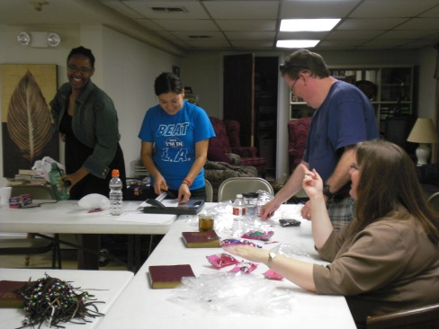
Teaching Workshops
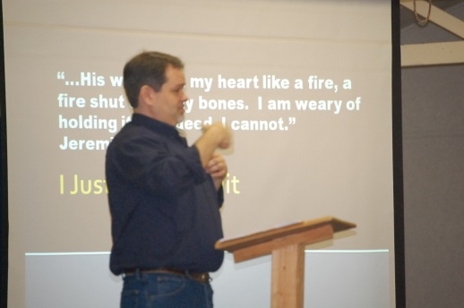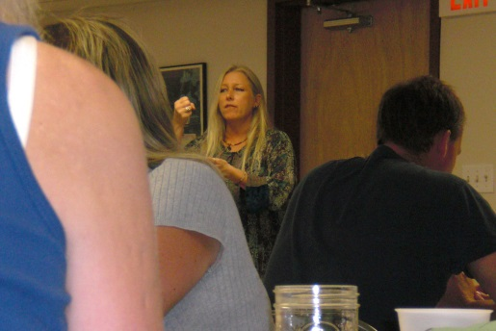
And lots of other fun stuff …
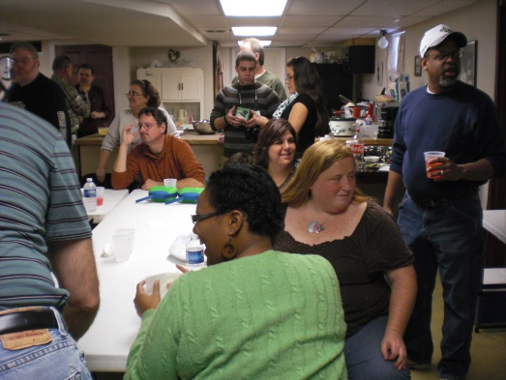

VP # 504 273 1152

E-mail: jclovas@gmail. Com, AIM: jclovas
Text #: 504-275-9707

Pager e-mail: jclovaspager@ gmail.com
Church address: 5320 and 5324 Canal Blvd, N.O., LA 70124
http://bblovas1.wordpress.com

