FREE
INTERPRETER INTERN/ MENTORSHIP GROUP

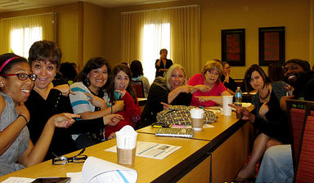

Provided free of cost to those who are seeking to become interpreters or work in a professional capacity within the hard of hearing, deaf and deaf/blind communities.
------------------------------------------
Do you want more info about upcoming community events, trainings and workshops in the Deaf community? Sign up for DEAF NEWS at Deaf Community News-CBBDC DEAF NEWS -- http://groups.yahoo.com/neo/groups/DeafCommunityNews-CBBDC/info

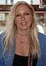
Mentor: Dr. Barbara Lovas, Th.D.
Nationally and State Certified Interpreter
RID CI/ CT, NAD IV, LCD V, Missouri Licensed
Proctor of EIPA Written

http://groups.yahoo.com/neo/groups/InternMentorshipASL/info
New Orleans Sign Language Services, LLC
http://www.neworleanssignlanguageservices.com
LinkedIn address: www.linkedin.com/pub/barbara-lovas/30/868/b68
E-mail -- bblovas1@yahoo.com, VP# -- 504 273 1152, Cell/Text – 504 722 2967

